**● Set Shark port in zeppelin/conf/zeppelin-site.xml**

<property>

<name>zeppelin.drivers</name>

<value>shark:hive://***master-ip***:10000,hive:hive://**masterip**:hiveport,exec:exec://</value>

<description>Comma separated driver configurations uri. </description>

</property>

● **Start the zeppelin server by running**

$ ./zeppelin/bin/zeppelin-daemon.sh start

**● Start the Shark Server by running**

$./bin/shark --service sharkserver

**● To start shark client run**

$./bin.shark -h localhost

**Enter the below address in browser to see the zeppelin UI**

<http://localhost:5050>

[If you want to run hive with zeppelin, add the command “@driver set hive;” before your hive queries in zeppelin interface.](mailto:@driver)

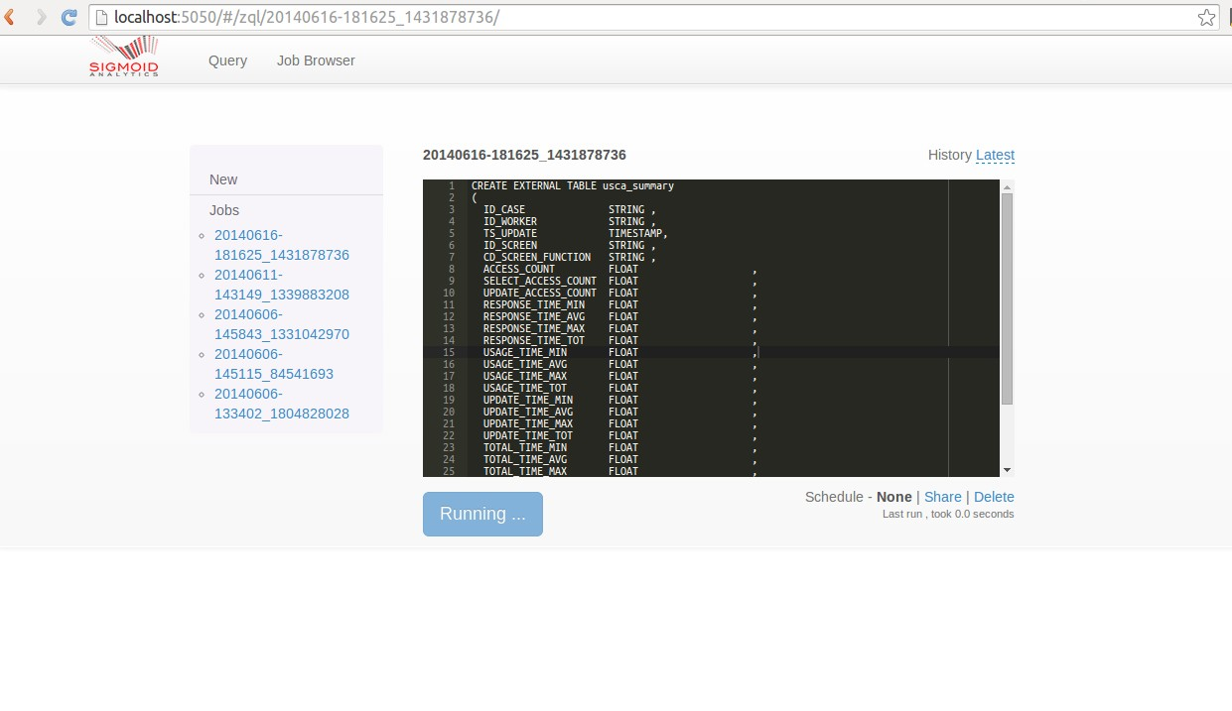

**Enter the below address in browser to see the shark UI**

<http://localhost:5050/sharkui/#/stages/>

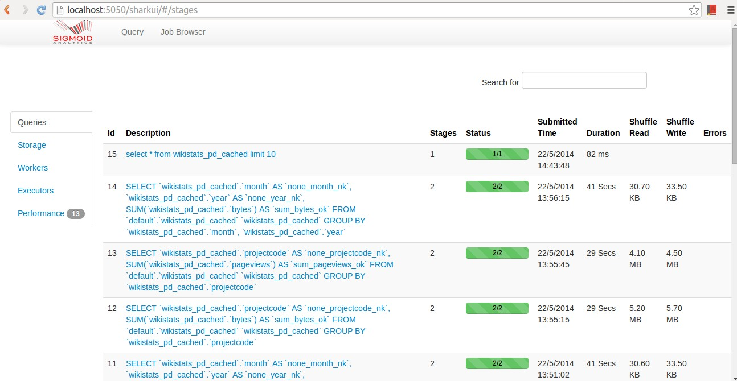

You can change the shuffle limit and time limit values for your UI in the

**/zeppelin/zeppelin-sharkui/src/main/swagger/js/controllers.js** by setting the corresponding variables - shufflelimit and timelimit (line 13-14).